Source Local Social Media Kit
Graphic are available in sizes for Facebook, Twitter and Instagram

Source Local
A series of facts highlighting the benefits of sourcing local.

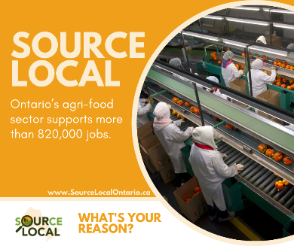 | We are proud to support the Source Local project, which strives to help Ontarians feel more connected with farmers and food producers. #SourceLocal | 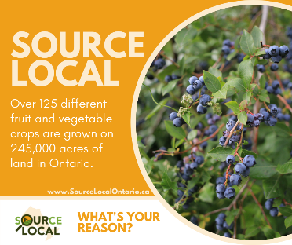 | Did you know that there are over 125 different fruit and vegetable crops grown in Ontario?  #SourceLocal
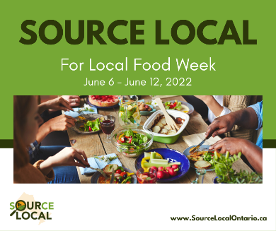 | Save the date! Local Food Week is taking place June 6-12, 2022. Local Food Week is a celebration of the bounty of the fresh, healthy food grown, produced and processed right here in Ontario. Farmers work every day to grow and produce safe and nutritious food for all Ontarians to enjoy. #SourceLocal | 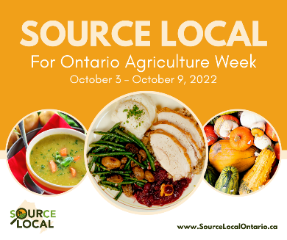 | Save the date! Ontario Agriculture Week is October 3-9, 2022. Ontario Agriculture Week is dedicated to celebrating the abundance of food our farmers produce, the Ontarians our industry employs, the rural communities we support and the economic engine we fuel. #SourceLocal
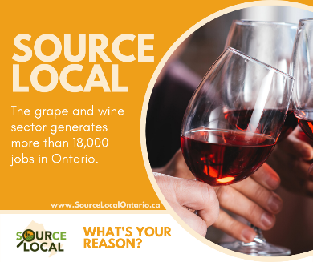 | Ontario is home to many regions with widely recognized wine grapes traditionally grown in more moderate climates. Find a local winery today!  https://www.vqaontario.ca/Wines #SourceLocal

My Reason
We all have a reason for the choices we make. What’s your reason for sourcing local?
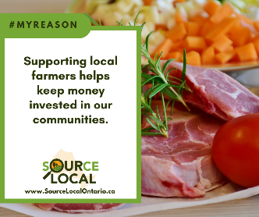 | #MyReason to #SourceLocal is that by supporting local farmers mean supporting the community. | 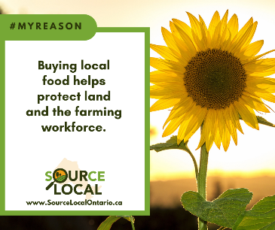 | When you choose local, you help create jobs and support economic growth in Ontario. #SourceLocal #MyReason
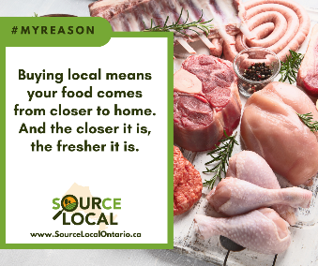 | When you choose local, you’re choosing food that’s grown closer to home. Closer means fresher! #SourceLocal #MyReason | 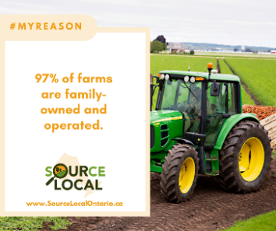 | #MyReason to #SourceLocal is that it supports families.
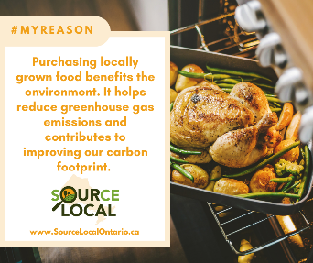 | #MyReason to #SourceLocal is that it’s good for the environment.

Customize any posts to encourage people to buy local, highlighting locations in your area of where they can visit
Use these to promote local ingredients and businesses in your area.

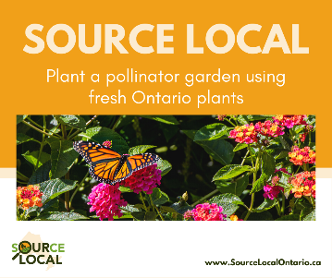 | Ontario flower growers offer a wide range of plants and flowers. Look for locally grown [insert item] at [insert location]. #SourceLocal
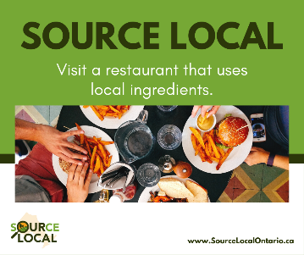 | Looking for a restaurant that sources local? You’ve got to try [insert restaurant] and their [insert dish]. #SourceLocal
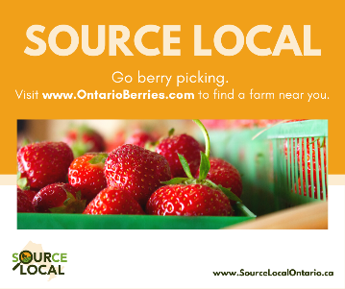 | Get outside this season by going berry picking! Join us at [insert name] this summer. #SourceLocal
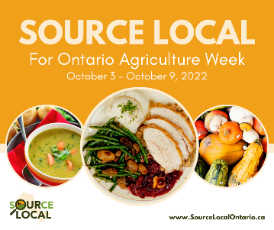 | Did you know that over 1,600 of Ontario’s farmers sell their products at farmers’ markets? You can find us at the [insert farmers’ market], which runs [insert day and time] #SourceLocal  Find a market near you by visiting https://www.farmersmarketsontario.com/find-a-farmers-market/
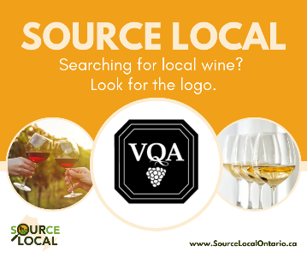 | Are you looking for a weekend adventure? Get outside with a trip to a [insert local winery]. #SourceLocal

